**🔐 Password Manager Application**

Welcome to the **Password Manager Application**, a simple and secure solution for managing your passwords efficiently. This application contains **three primary screens**, each tailored for specific password operations.

**🗂️ 1. Password List**

This is the **main screen** and can be accessed via the primary URL. It displays all saved passwords and includes a sidebar menu titled **"Password"**.

**🔎 Feature 1: View Passwords**

Browse through the list of all passwords stored in the database.

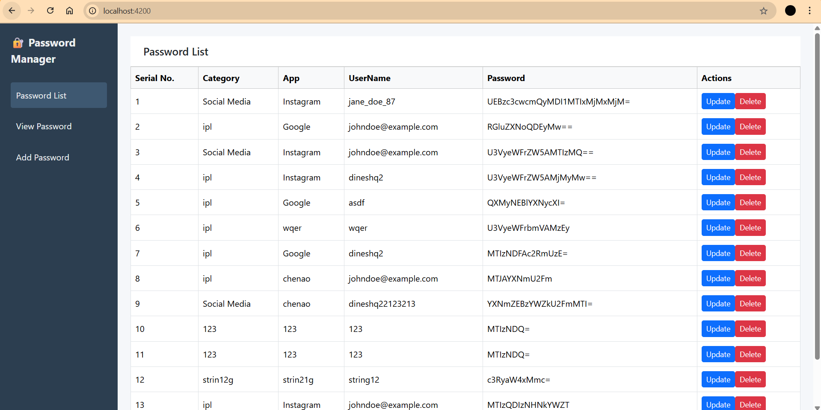

**📝 Feature 2: Update Password Details**

* Click the **Update** button to populate the input fields with the selected record.
* After editing the details, click **Update Password** to save changes.
* The application will then **navigate back** to the Password List screen.

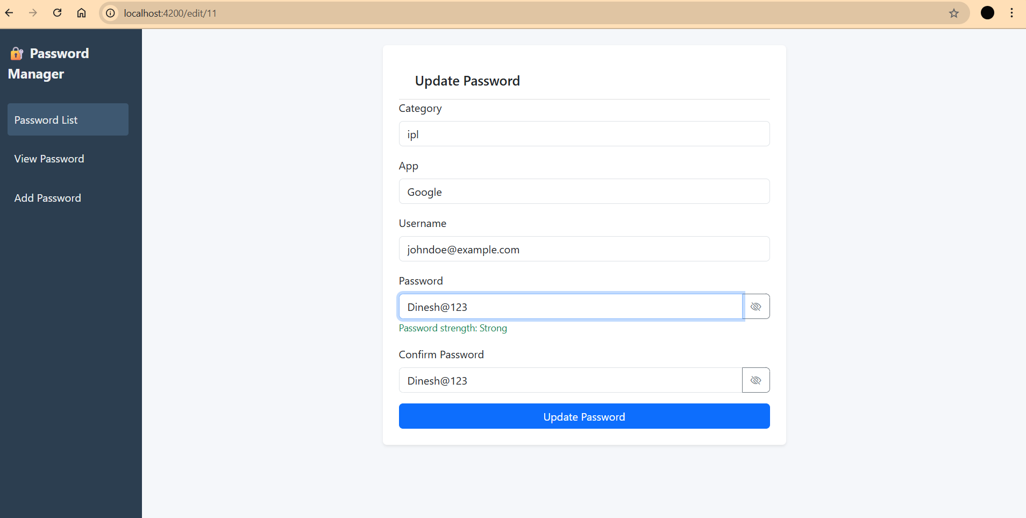

**🗑️ Feature 3: Delete Password**

* Click the **Delete** button next to a password entry.
* A confirmation popup will appear — click **OK** to confirm deletion.

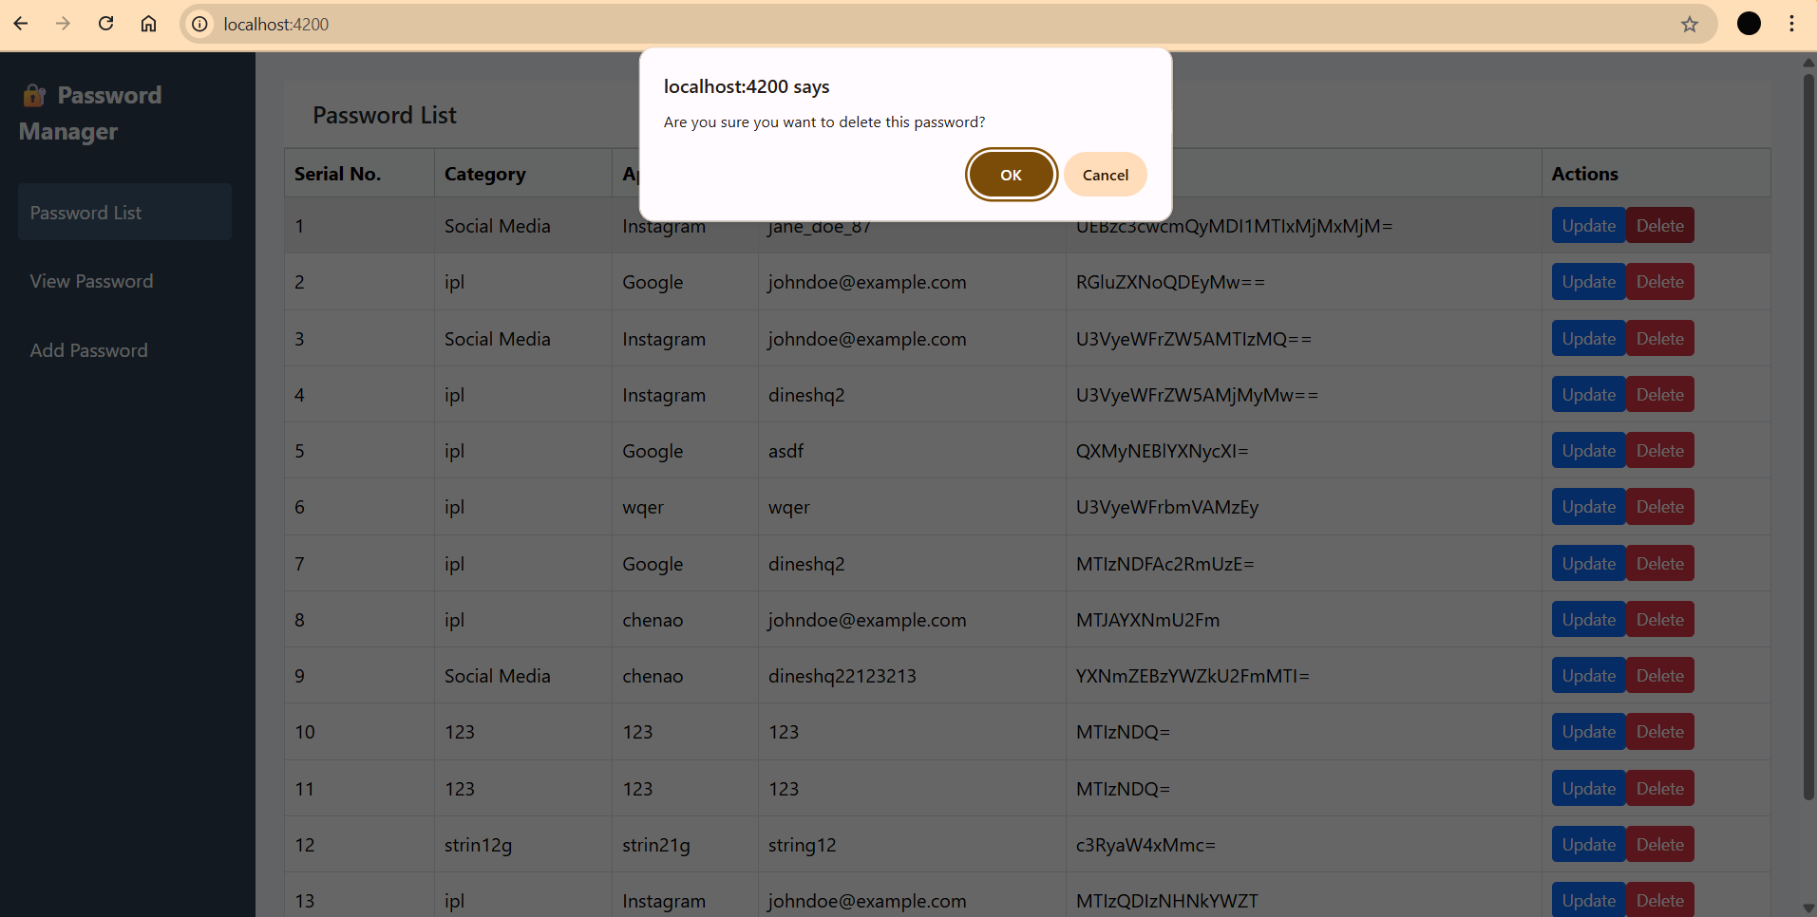

**🔍 2. View Password**

**🔐 Feature: Decrypt and View Password**

This screen is designed to help users **view a decrypted password**.

* Enter the **Username** in the input field.
* Click the **Get Details** button.
* The system will display the **decrypted password** for the corresponding user.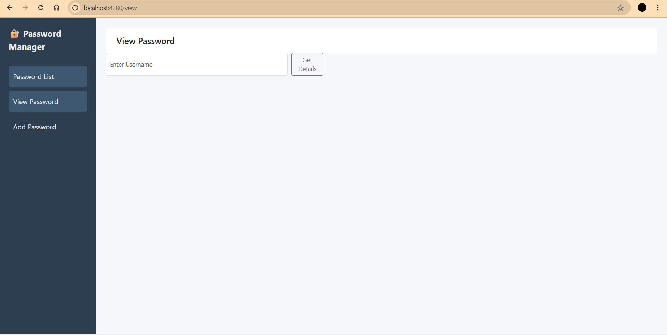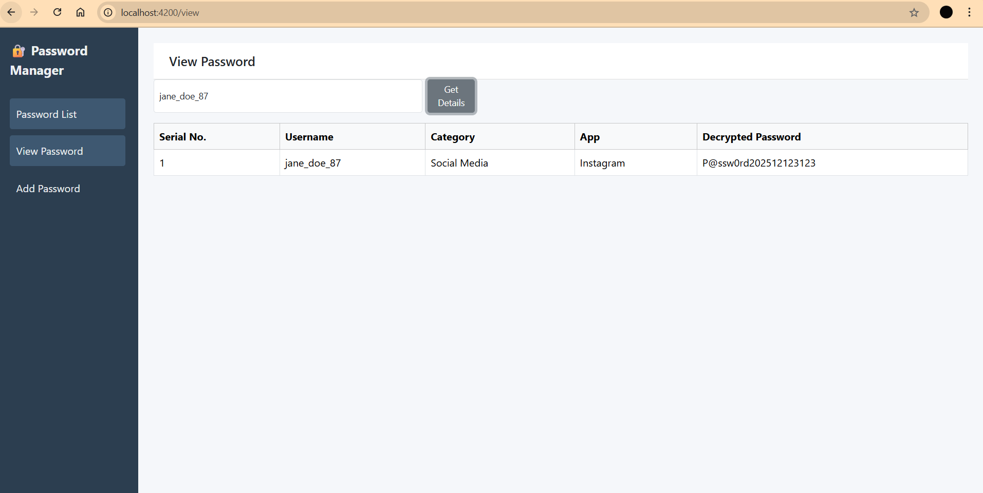

**➕ 3. Add Password**

**🧾 Feature: Add New Password**

This screen is used to **add new password entries**.

* Fill in the required password details.
* Click the **Add Password** button.
* The data will be securely stored in the database.

